1. 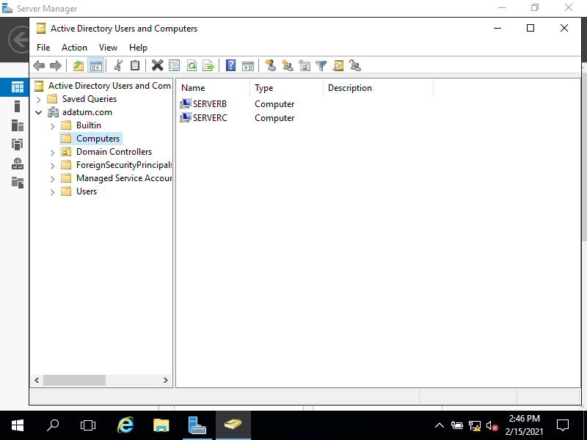Screenshot of A, with computers
2. 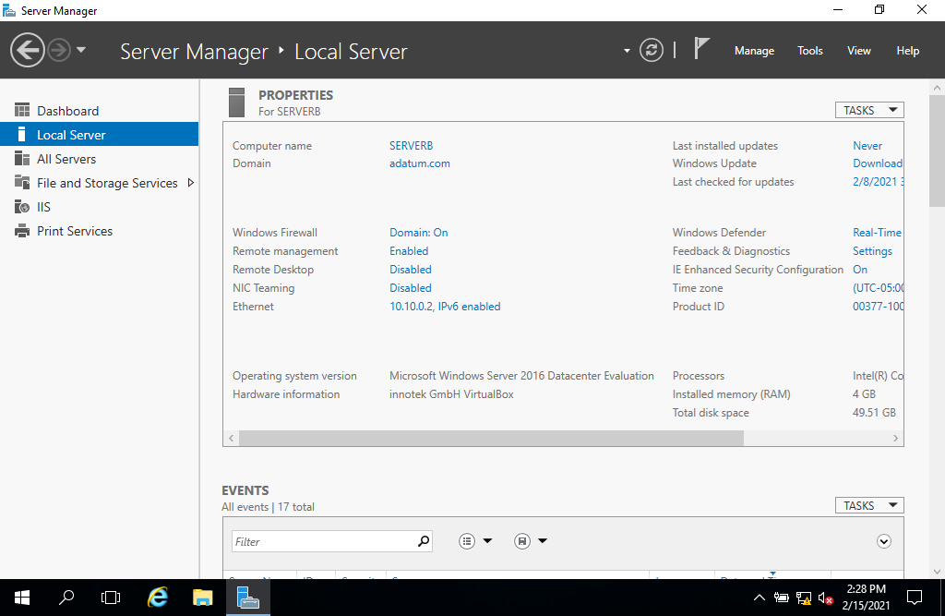Screenshot of B with workgroup as adatum.com